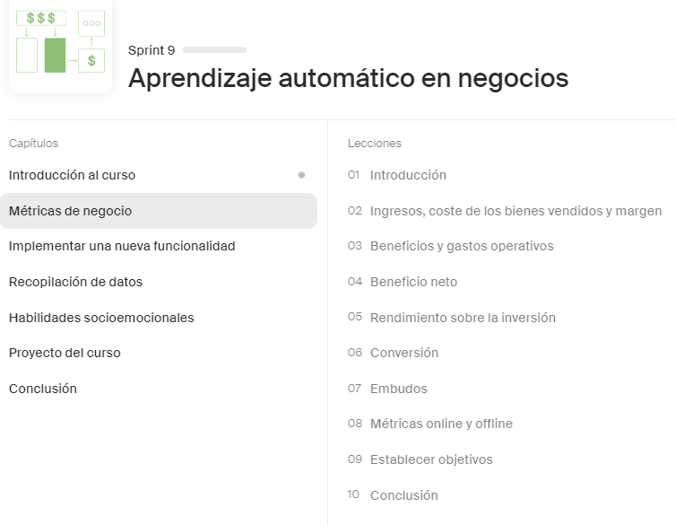



INTRODUCCION

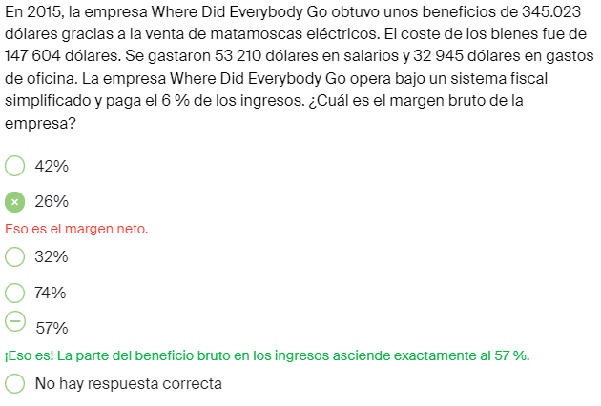

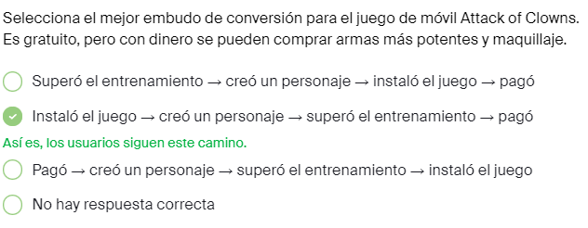

[Guía de KPIs para Google Play Apps y Juegos: Introducción a las métricas](https://medium.com/googleplaydev/a-kpis-guide-for-google-play-apps-and-games-intro-to-metrics-214da979f5a2)